December 13, 2021

React: The Big Picture

Course Overview

<div \*ngFor=”let user of users”>

<div v-for=”user in users”>

{{#each user in users}}

“HTML” in JS

{users.map(createUser)}

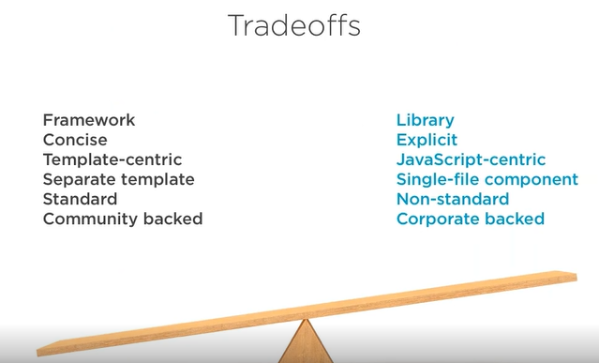

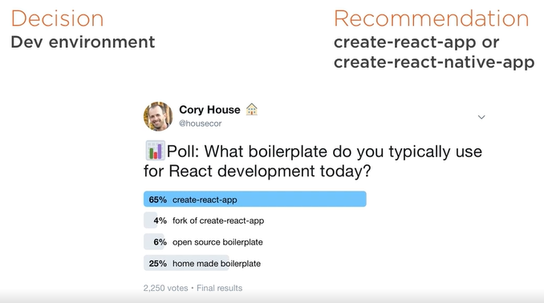

Potential use cases for React

What sets React apart

Key projects to consider

Approaches to mitigating downsides

Five key decision you need to make

You’ll understand React and its ecosystem at a high level.

Prerequisites:

No prior knowledge required

Why React?

-Intro

-Course Outline

- Why React?

-Tradeoffs: inherent in React’s design

-Why not React? Concerns about React and approaches for how to mitigate these concerns.

-History

-2011: Created by Facebook

-2012: Used on Instagram

-2013: Open Sourced(After using it for 2yrs FB open sourced it)

//React ran contrary to popular practices that ran by placing markup and logic together in a single file. Each React component is a separate concern.

-2014 Embraced by many large companies

-2015 React Native release

// React Native is a related library that allows you to create native mobile applications for IOS and Android using React. In April of 2016, React reached another

-2016 React 15 released(previous version was 0.14)

//Helps convey that React is not a stable platform with over five years of active development and heavy production usage to back it up.

-Today Over 50k components at Facebook

Full-time dev staff

Used by many in Fortune 500

//React is used not only on Facebook but Instagram and React Native is used on mobile devices

-Why React

-Reason 1: Flexiblity

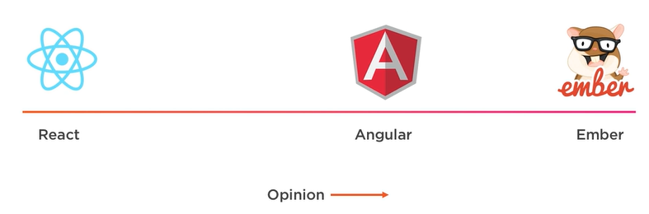

React is remarkably flexible. React is more flexible than opinionated framework Angular or Ember. React is a library, not a framework. As you’re about to see, React’s library approach has allowed it to evolve into remarkably flexible tool. When React was initially created, it had a single, focused use case. It was creating components for web applications.

-It’s ecosystem has grown to cover a variety of use cases.

-You can generate static sites with React using popular tools like Gatsby and Phenomic..

-Use React to build native mobile applications

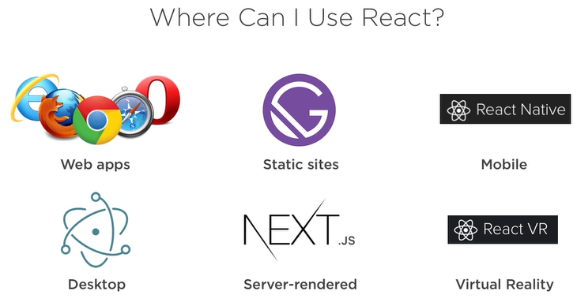

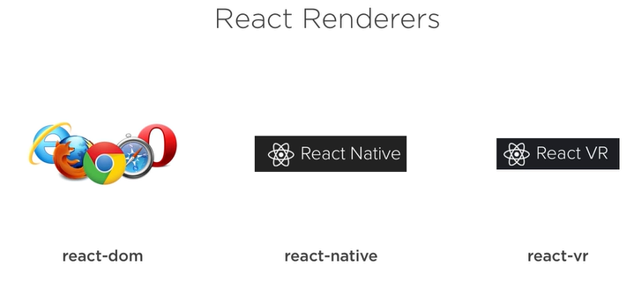

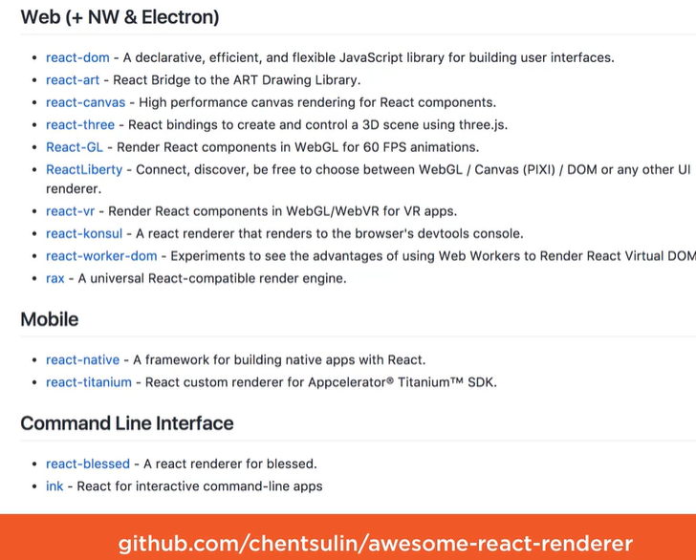

-React Dom >> Server-Side Rendering

ReactDomServer.renderToString() << useful when you want to render your react components on the server. So this means you can use React to replace your traditional server- side rendering technologies.

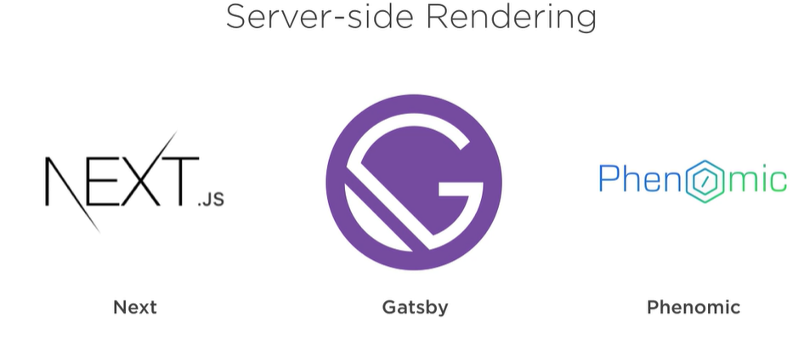

-Can easily use React to deploy plain HTML and JavaScript files to any host.

-Reason 2: Developer Experience

-import React from ‘react’; 🡨import React using JavaScript import statement

Function HelloWorld(props) { 🡨 declare a component using standard JavaScript function

Return <div> Hello {props.name}</div>

}

The function receives variables via an object called props.

-You can also declare a React component using a standard JavaScript class.

React render is a JSX file

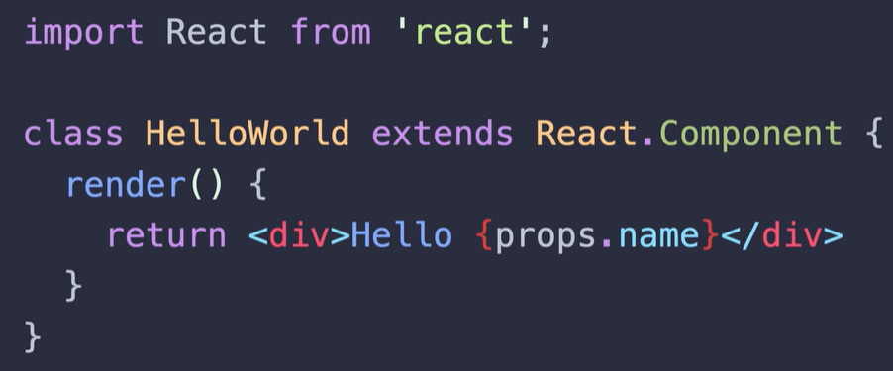

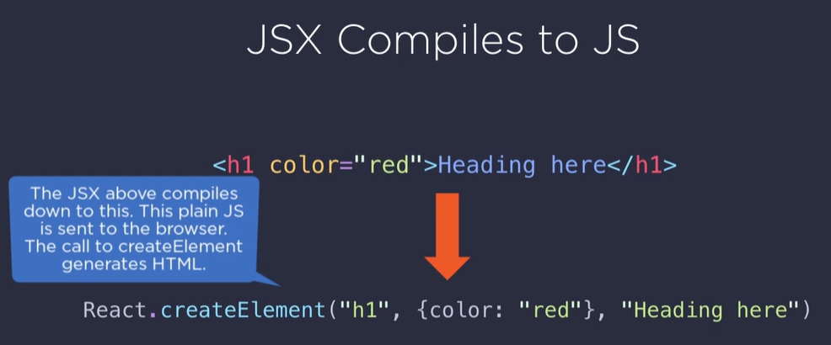

This final parameter contains calls to other elements if you have other nested markup. So if you can avoid JSX if you want to want to write this JavaScript yourself. But using JSX is easier to read and nest.

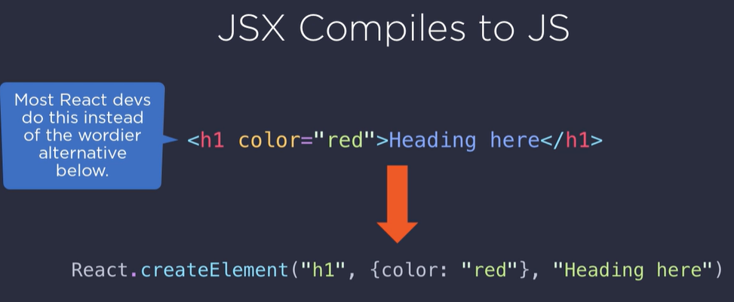

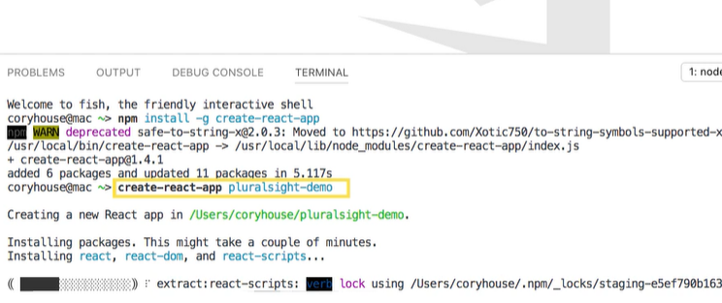

-npm start

-If there’s a mistake, a detailed error message shows in the browser. If you forget to close a tag within JSX, I get to compile time message about the precise line where I made a mistake.

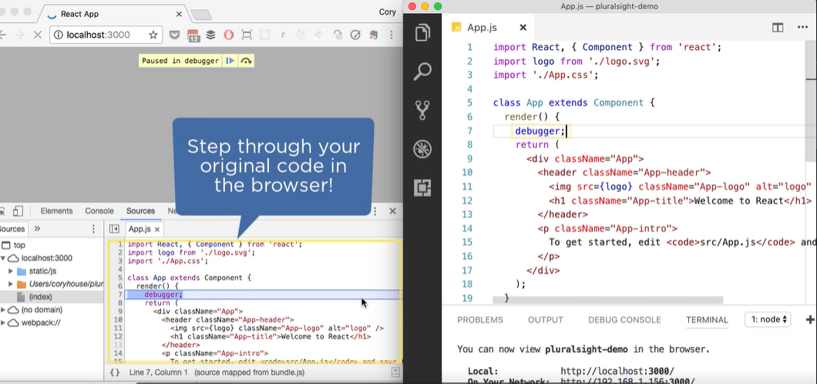

-If you need to debug your code, it’s easy to set a breakpoint and view the original code in the browser. Through the power of source maps, you can see the original code that you wrote in your editor displayed within the browser.

-Automatically works with create-react-app

-Or use codesandbox to experiment with React, share your work and even build your entire app.

-Reason 3: Corporate Investment

-Created and maintained by Facebook

-A codemod is a code base to automate changes. Easily resolve breaking changes by running a script. So with React codemod you can automatically update older React components. Easily resolve breaking changes by running a script.

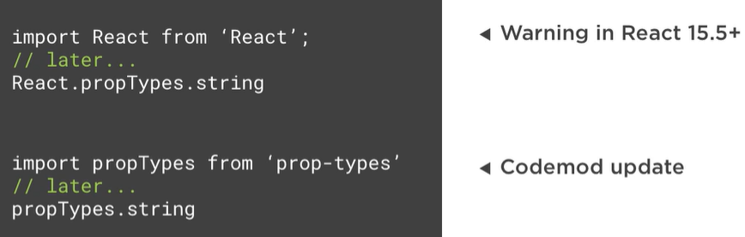

-Reason 4: Community

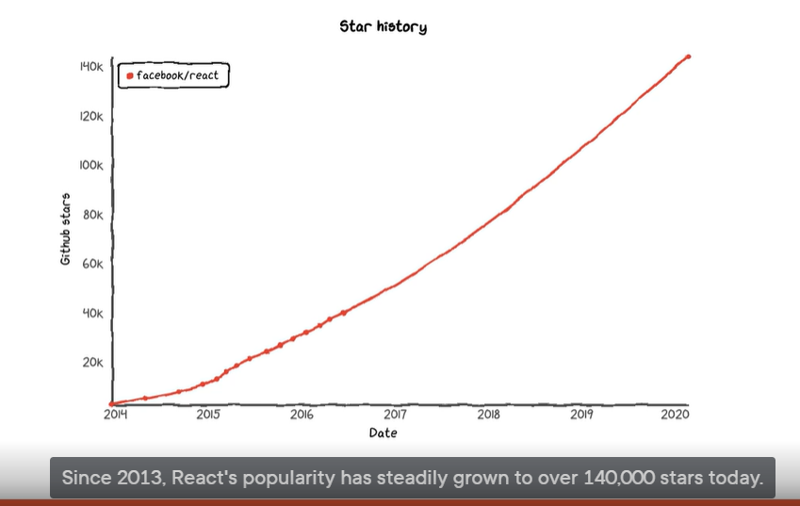

-One of GitHub favorite repositiories and over 6 million download every week. 8k companies use React.

-Reactiflux

-ReactJS on StackedOverflow

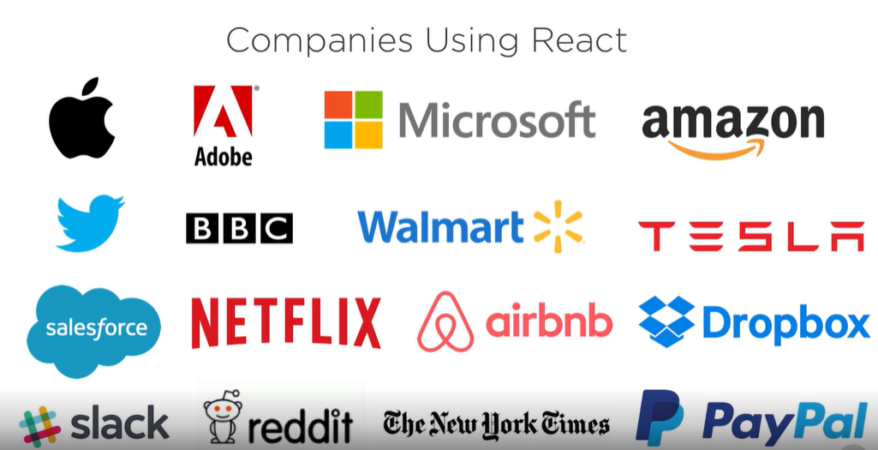

-github.com/enaqx/awesome-react

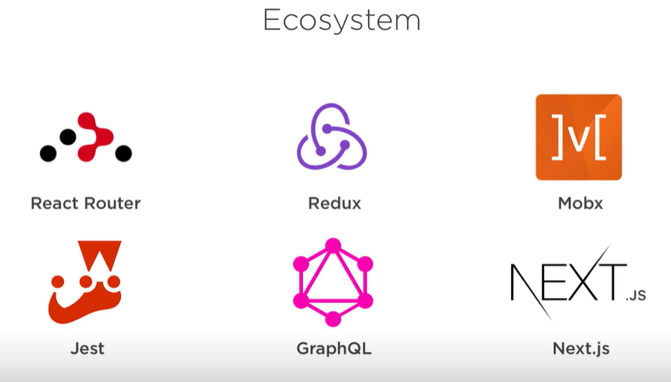

- Reason 5: Performance

-Why virtual DOM?

-Updating DOM is expensive

-So React minimizes DOM changes

Without Virtual DOM

Blindly update DOM using new state

With Virtual DOM

Update the DOM in the most efficient way

-avoid layout thrash

-saves battery & CPU

- enables simple programming model

-Reason 6: Testability

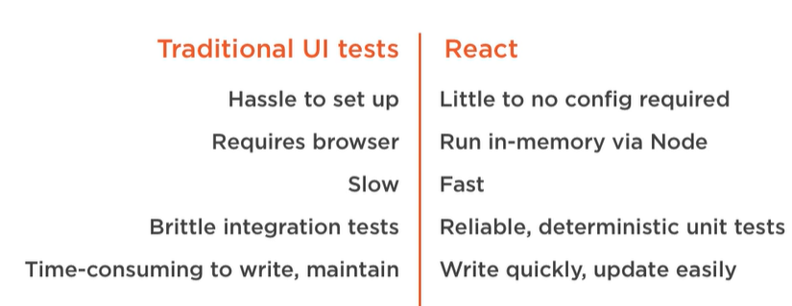

Pure Function: Always returns same output for a given input. I.E below:

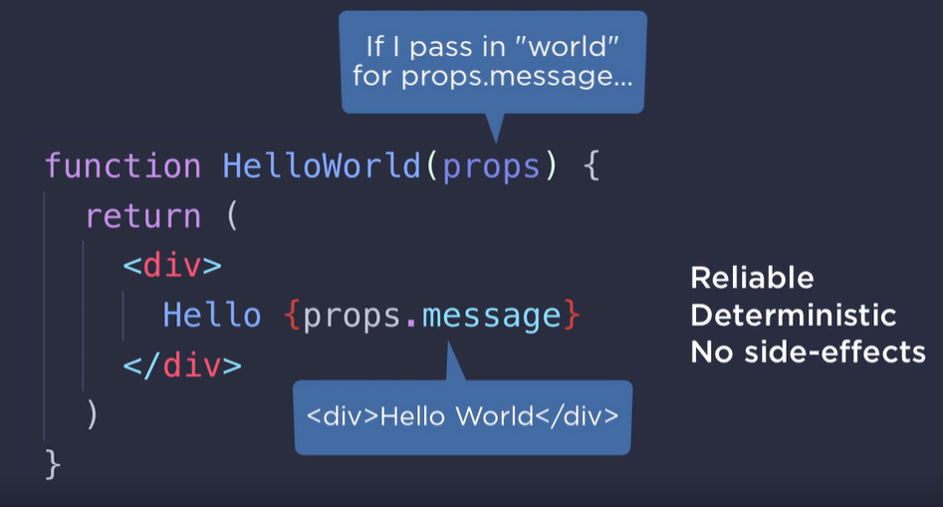

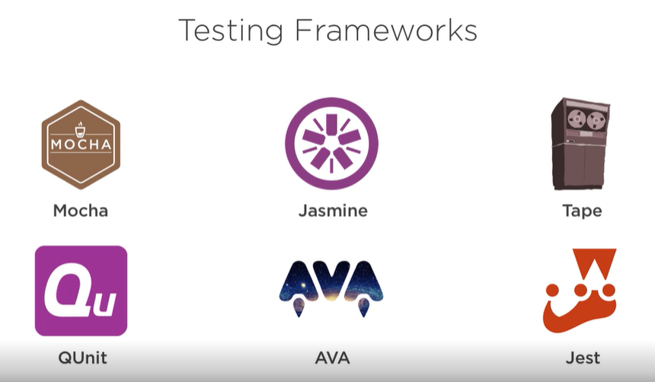

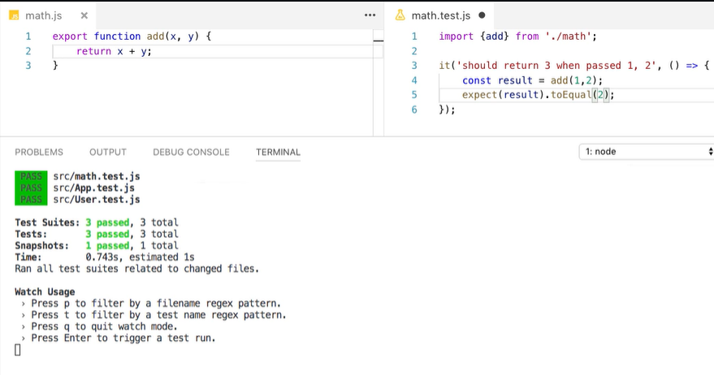

SNAPSHOT TEST ON JEST:

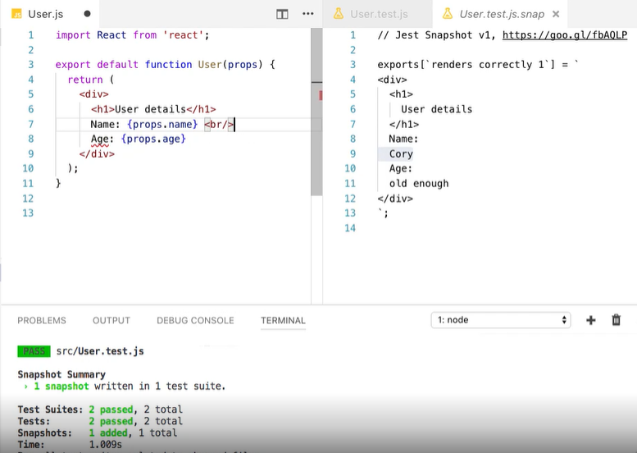

-Summary

Why React

-flexibility

-developer experience

-corporate investment

-community support

-performance

-testability

Tradeoffs

-Intro

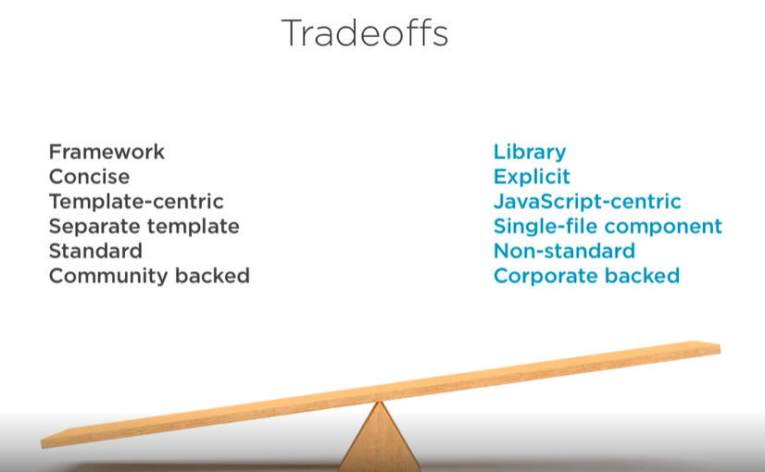

-Tradeoff 1: Framework vs Library

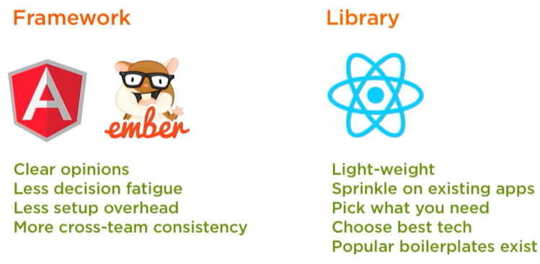

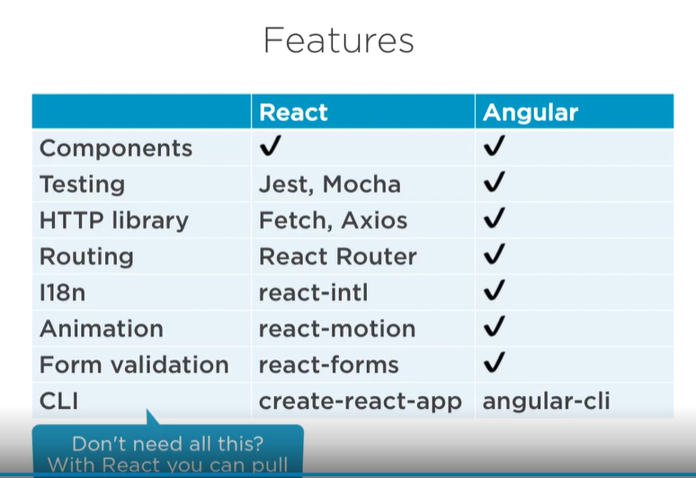

-Tradeoff 2: Concise vs Explicit

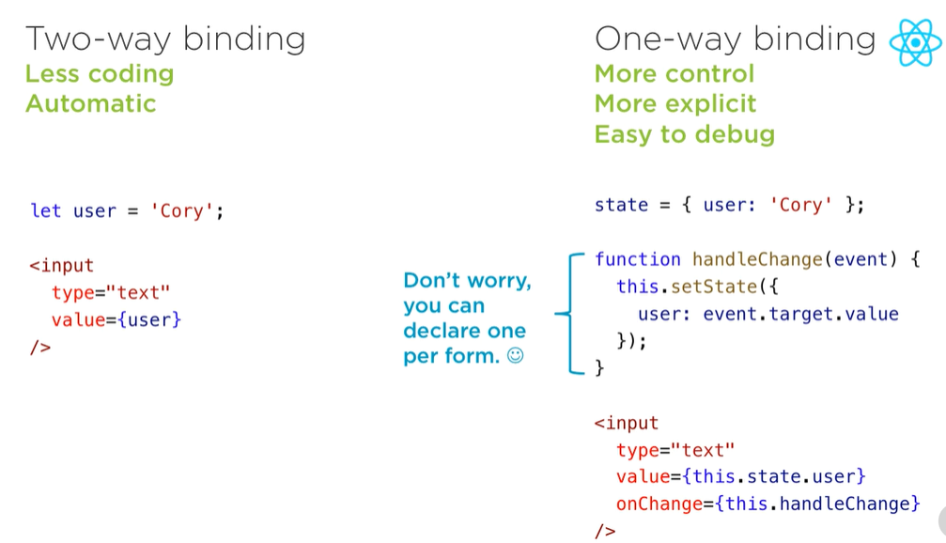

-Tradeoff 3: Template-centric vs JavaScript-centric

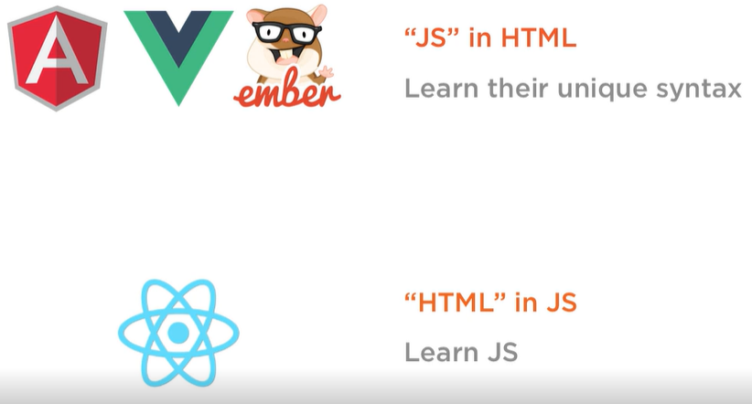

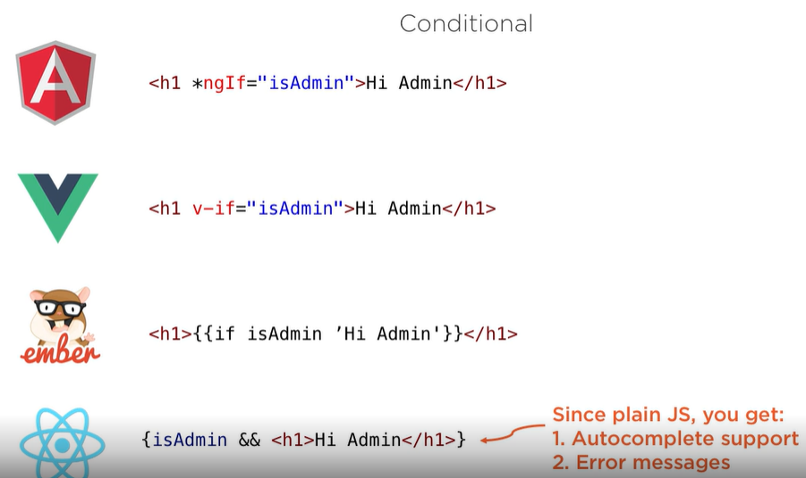

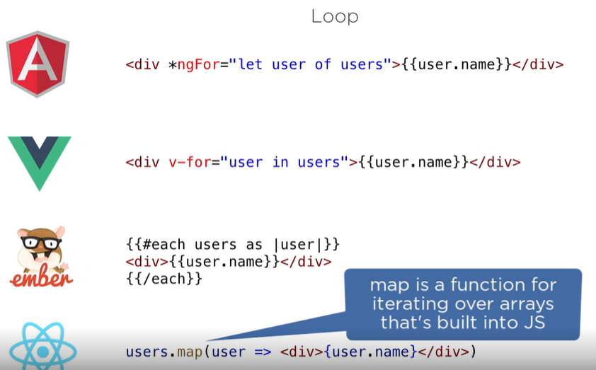

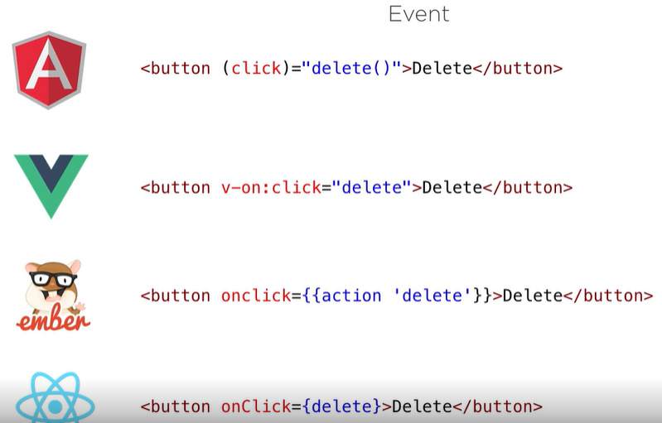

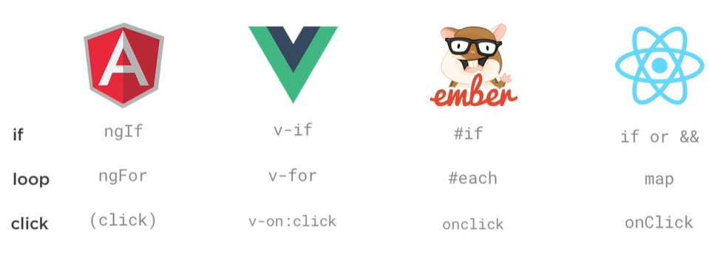

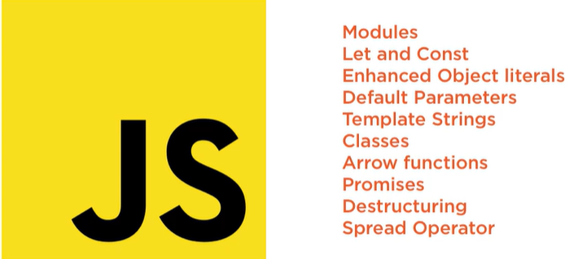-

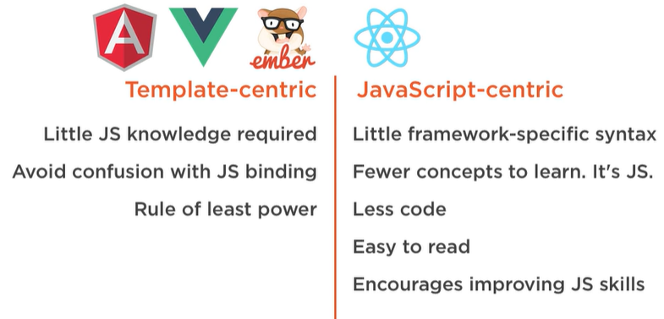

-Tradeoff 4: Separate vs Single File

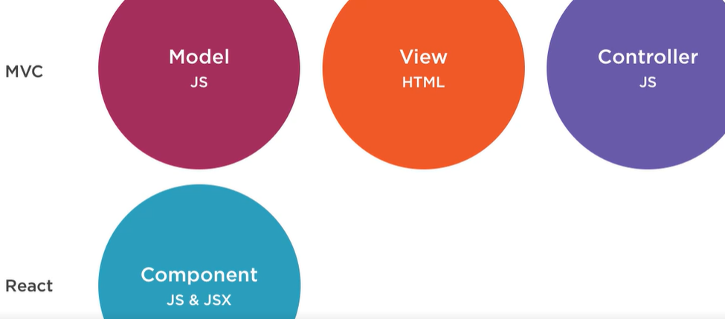

`` 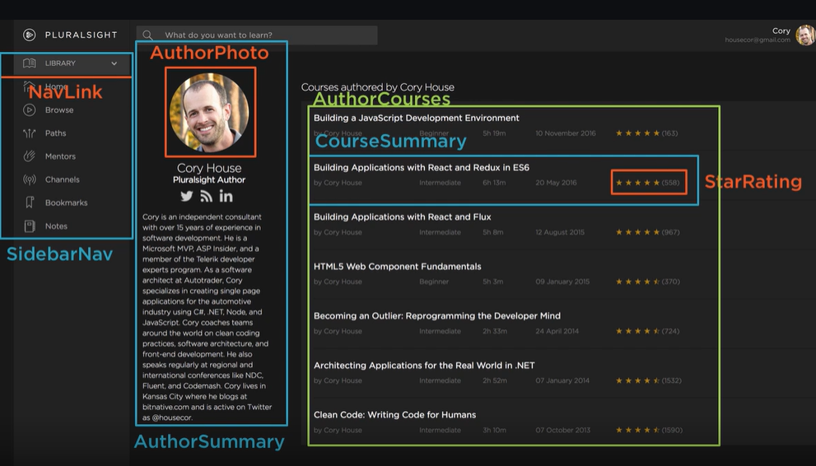

-Tradeoff 5: Standard vs Non-standard

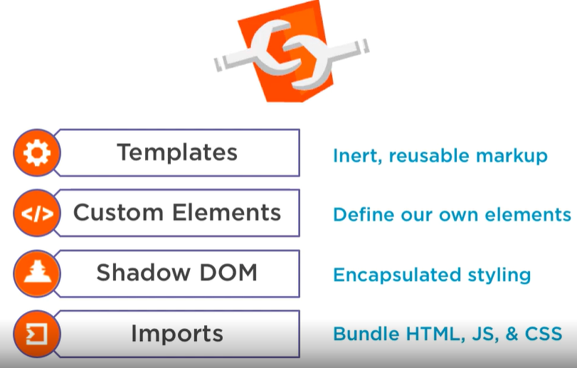

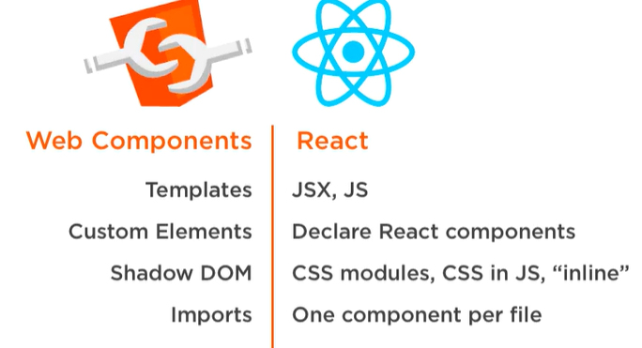

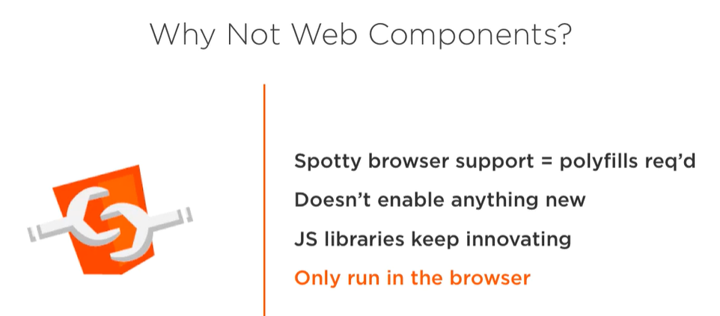

-Tradeoff 6: Community vs Corporate

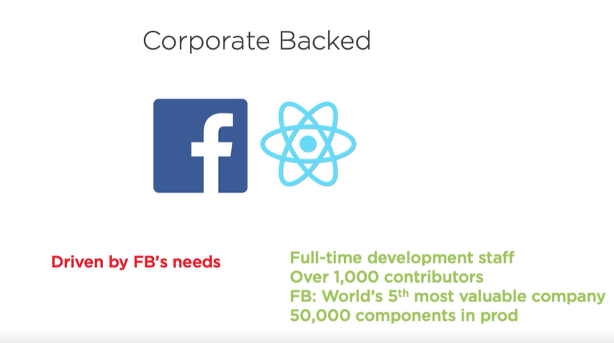

Why Not React?

-Intro

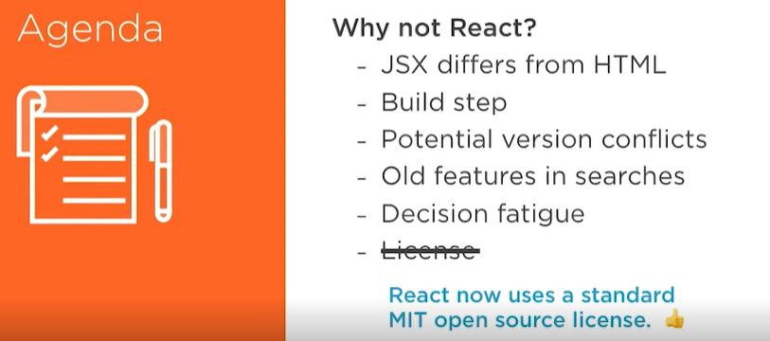

-Concern1: HTML and JSX Differ

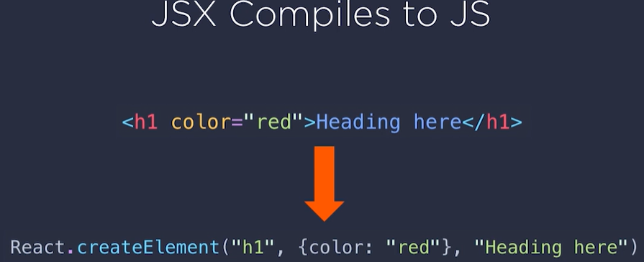

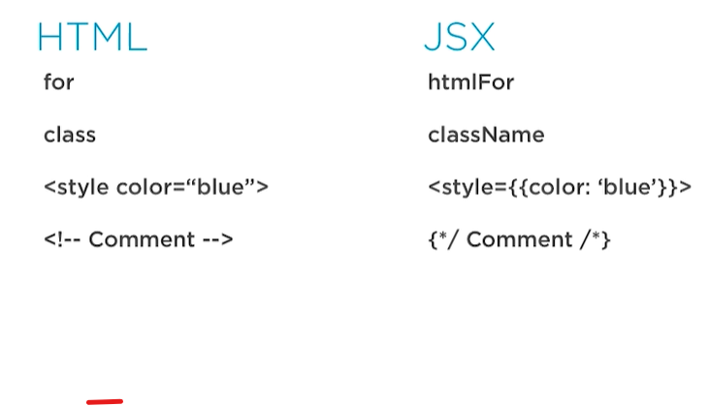

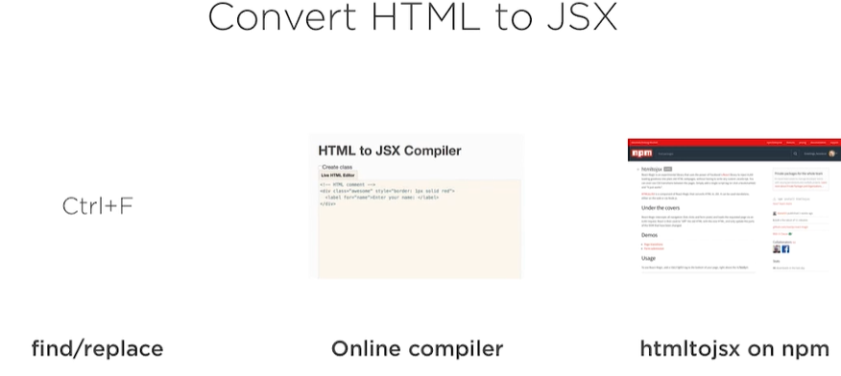

-HTML TO JSX Complier: magic.reactjs.net/htmltojsx.htm

If you have a lot of html to convert to JSX:

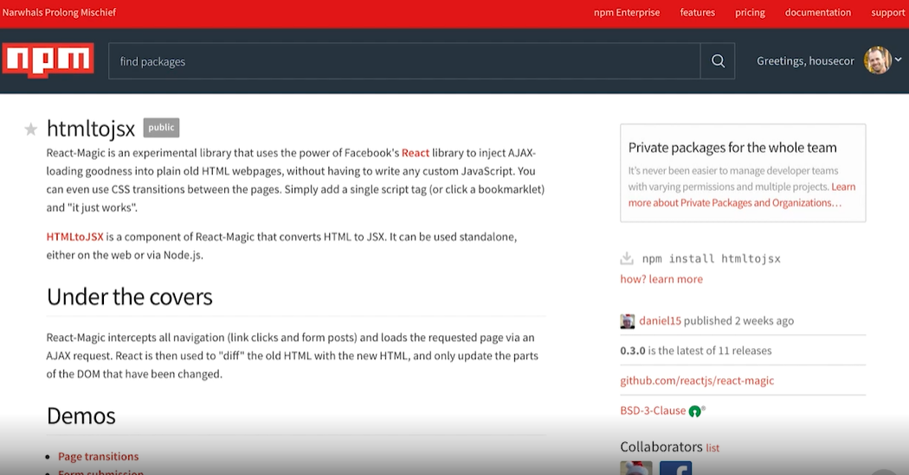

-Concern 2: Build Step Required

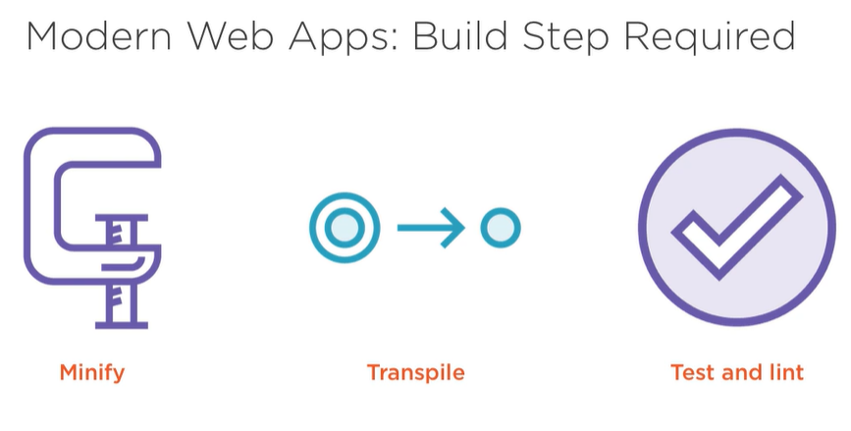

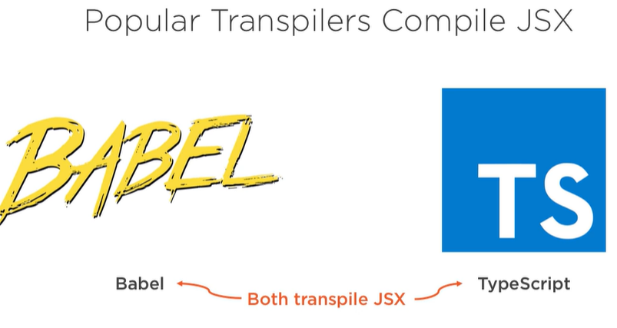

-Concern 3: Version Conflicts

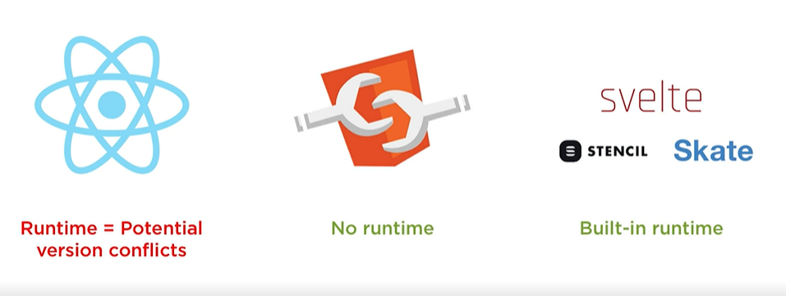

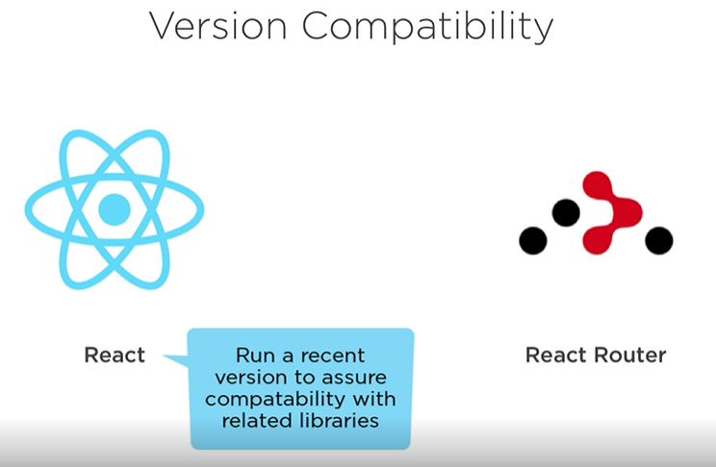

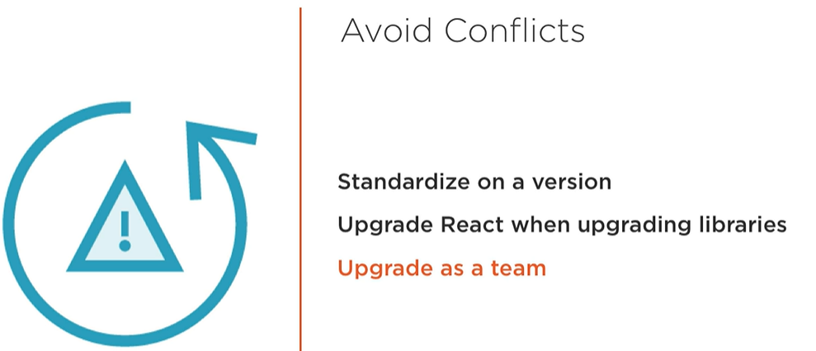

-Concern 4: Outdated Resources Online

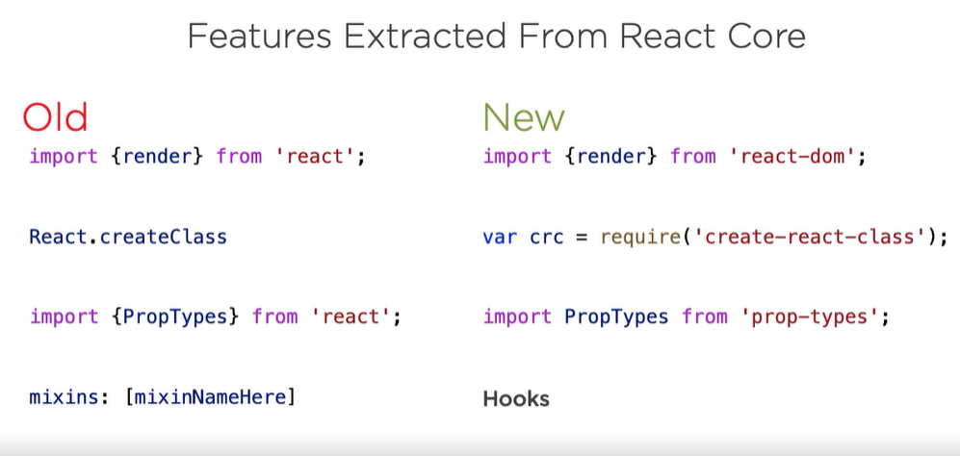

-Concern 5: Decision Fatigue

-Dev environment: over 100 boiler plate projects on Github

Javascriptstuff.com/react-starter-projects

Start with create-react-app

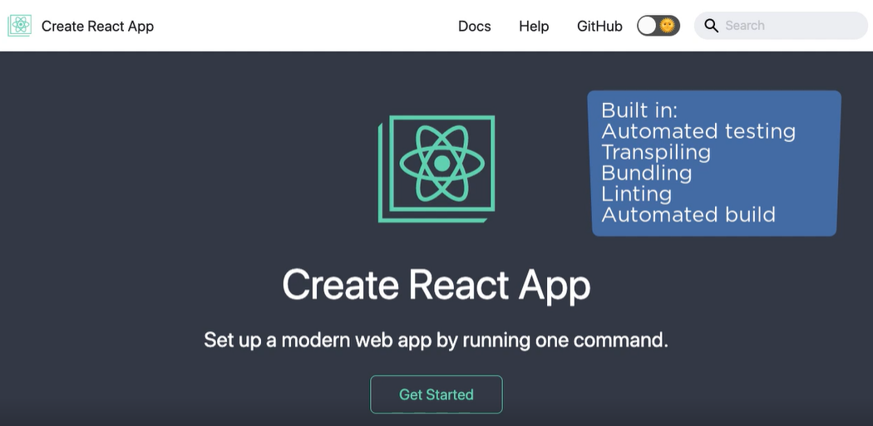

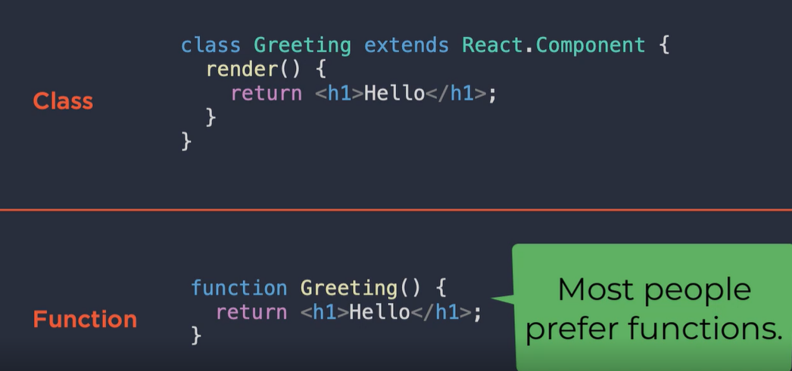

-Classes or functions



-Types: PropTypes, TypeScript, or Flow

PropTypes: only ran during development and runtime

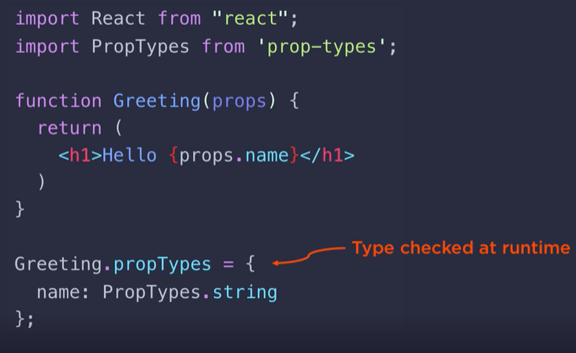

TypeScript: C++ or Java, checked at compile time

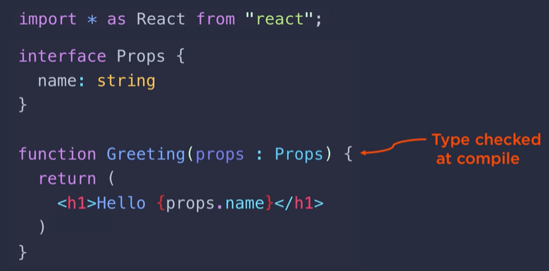

Flow: static type checking, type annotation to plain JavaScript, annotate the top of each file

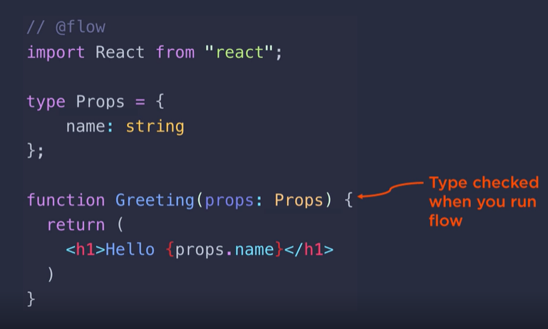

-State: Your App’s Data

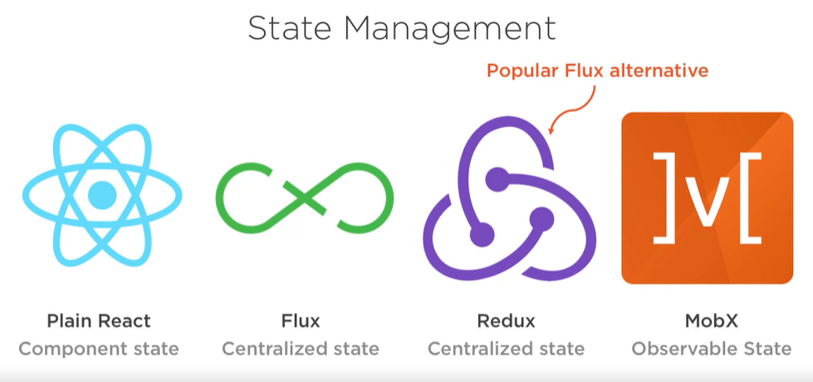

React works great alone.

-Styling: Use whatever you know.

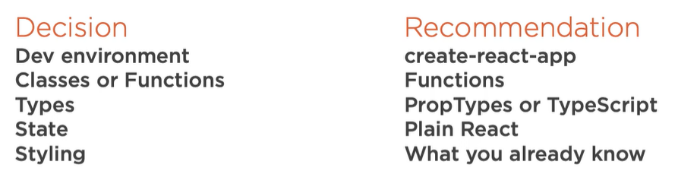

-Next steps

Lots of react courses!!!

